Sprint Report Document

# Heading

Document name: Sprint Report Document

Sprint {2}

project title: Pick a Dish

Team number: 5, Section: 47406

Team member 1: Sara al-meshrai, ID:435202339

Team member 2: Nora alkhunifer, ID:435201094

Team member 3: Asmaa Alrubia, ID: 435200178

Sprint start at: 26/10/2017

Sprint competition at: 8/11/2017

# Sprint Review

|  |  |
| --- | --- |
| **Work completed** | **not completed** |
| As a user, I want to see a list of dishes, so that I browse all the types shown | As a user, I want to search by dish’s name, so that I save some time. |
| As a registered/log in user, I want to able view my profile page with my avatar, name, and numbers so that I can see my profile based on my specific info and tips | As a user, I want to able to ' like ' mark a dish so that my favorites dishes are arranged |
| As register user off the app, I want to add a new dish in the app, so that added on database and dishes list for all users | As a user, I want the dishes list ordered by high rating, so that I know what is the best dishes. |
| As a developer, I want to select design and style to all app pages and download needed elements. | As a developer I want to link the implemented project to ionic dashboard and link all members with it in order to make it public for all clients |
| As a user, I want to create account in pick a dish application using my email so that If I had forgotten my password, I may click on "Forgot Password" to receive instructions via my email on how to reset my password. | As a user of app, I want to rate any dish in app so that the system will add my rating on that dish |
| As a user, I want to be able to sign out from my account at any time so that I make sure that it’s secured and won’t be accessed by someone else, or to sign in again using a different account. |  |
| As a user, I want to be able to change the name of my profile at any time so that the name that appears to others will be changed by default. |  |
| As a user, I want to be able to add a bio at any time so that I can till other users a little about myself. |  |
| As a user, I want to be able to edit my bio at any time so that I can update my small description and facts whenever something change about myself. |  |
| As a user of app, I want to view dish rating and number of raters who rate the dish |  |

# Sprint Retrospective

Actions to stop doing

1. The team should stop assigning many user stories in the sprint, because one of the team members dropped the course.
2. The team should stop selecting user stories to an upcoming sprint without a prior knowledge on how to implement them, to avoid a sprint failure.
3. The team should stop working separately, because that delays the work progress and waists time in fixing errors and generating repetitive steps.

## Actions to start doing

1. The team should start working on one server and update it frequency, since the conflict in code generates a lot of errors.
2. The team should schedule more group work sessions, since these are very effective at getting work done.
3. The team should double working hours, since plan tasks for previous sprint doesn’t as expected.

## Actions to keep doing

1. The team should continue training on ionic ,since we don’t have the full knowledge .
2. The team should continue helping each other ,since we have different skills .

# Metrics

## Sprint Burndown

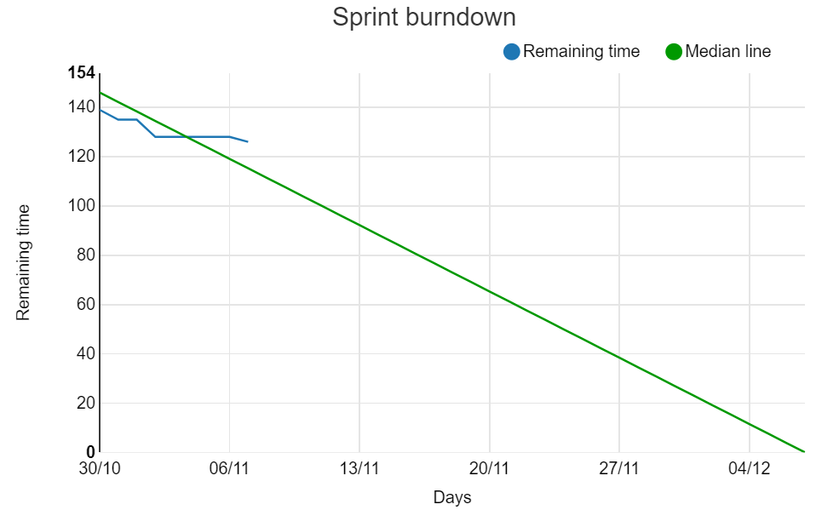

# Some screen shot of our app

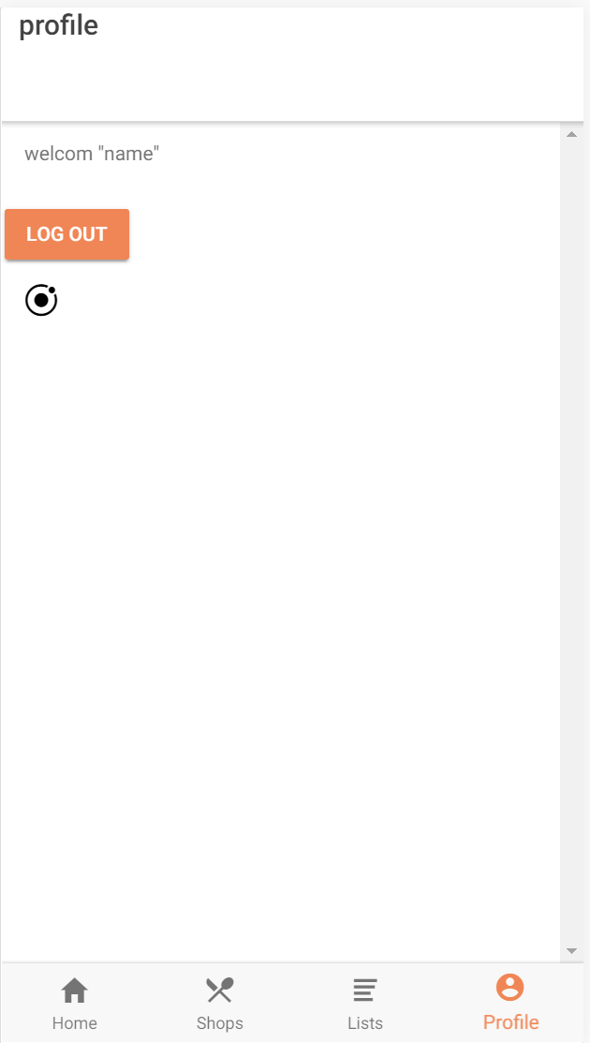Figure "current profile page"

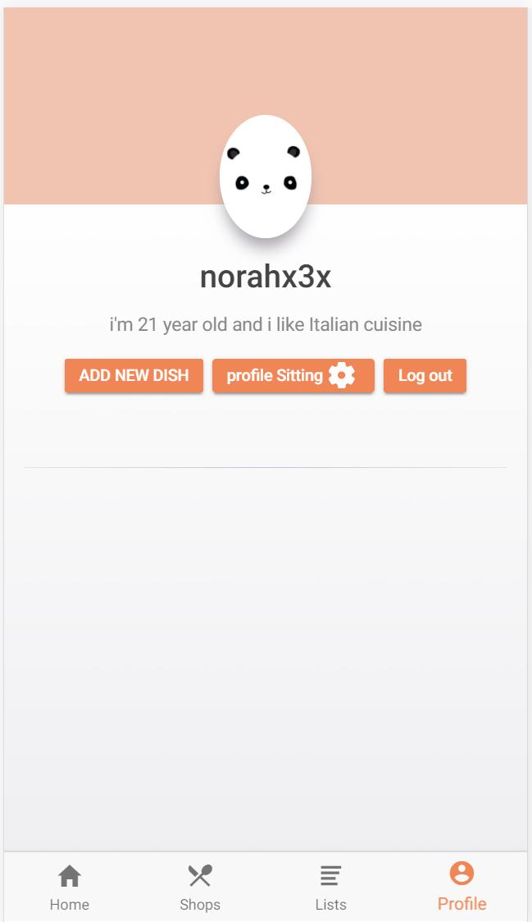Figure " Previous sprint profile page”